SoGross Amalgamated Analytical Competitor’s Product Report

First Author: Emily Perrone

Second Author: Charlie Nitschelm

Dear SoGross Algamated,

Over the past week, we have been working with the cross section you prepared for us. Per your request, we performed an elemental analysis and have written a report on many different visible components in the product using our scanning electron microscope equipped with an energy dispersive spectroscopy.

It was a pleasure doing business with you, and I hope to be able to work for you again. Feel free to contact me with any questions or concerns you may have. Also, if there is any other information you want included I would be happy to incorporate it within my report.

Regards,

The Material Science Analytical Services Team

SoGross Amalgamated requested an elemental analysis of the cross section on one of their competitor’s products. The sample’s cross section was fully prepared for us upon receiving it. The Material Science Analytical Services Team provides us with a scanning electron microscope (SEM) equipped with an energy dispersive spectroscopy (EDS). The following paragraphs summarize our observations in the form of annotated images and a brief description of our observations.

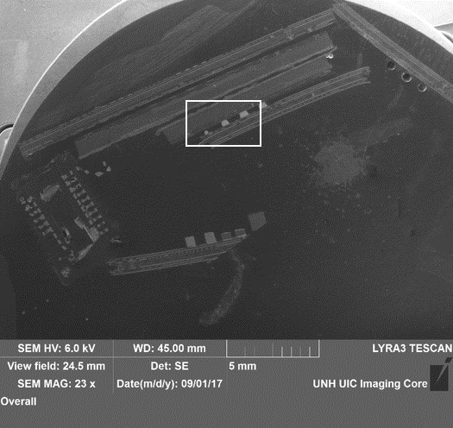

Figure : Low magnification of the specimen within the entire cross section

To conduct our elemental analysis, we used a Tescan Lyra 3 Field Emission SEM equipped with an EDS. The specimen of the cross section was already prepared by SoGross Amalgamated. Our data is only semi-quantitative. We cannot detect the presence of elements with concentrations below approximately 0.1% and we cannot detect elements with atomic numbers below carbon.

Figure 1 shows our cross section zoomed fully out. Figure 2 shows the zoomed area outlined by the white box in figure 1. Within figure 2 we have areas sectioned out where we used our SEM equipped with an EDS to analyze the cross section. We first analyzed Area 5A shown in the top left of figure 2 and then within that area we look at Area 5A Zoomed. Next we look at Area 5B which is outlining those two white dots below and to the right of Area 5A pictured in figure 2. Then we analyzed Area 5C shown in the square towards the bottom middle of figure 2.

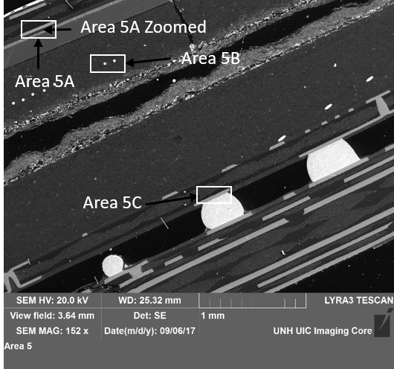

Figure : Zoomed in area within the square shown in figure 1

To analyze figure 3 we used our SEM containing our EDS. The EDS spot selection on the top of the image within the light grey background in Figure 3 contains copper and a little carbon. The next area selection we analyzed is in the center of our picture within the dark grey area. This area contains copper, oxygen, silicon, sulfur, barium, and small amounts of copper, magnesium and aluminum. Our third area we did an elemental analysis on is located within the black and white mixed background below and to the right of our first selected area. This area contains mostly silver and carbon, with a little oxygen, magnesium, aluminum and silicon. Our last spot we analyzed is located in the bottom right corner and contains silicon.

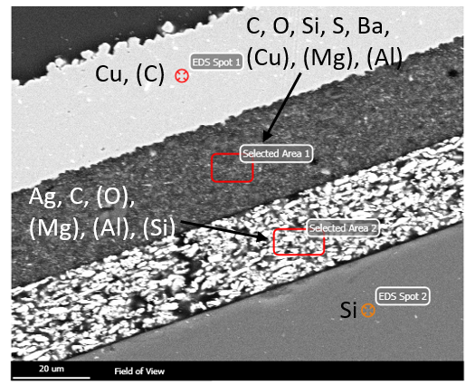

Figure : Zoomed in picture of Area 5A shown in figure 2

The next area we analyzed using our SEM is pictured in figure 4. This area is a zoomed in section located between selection area 1 and selection area 2 located on figure 3. Our first spot we analyzed containing silicon, oxygen, and a little carbon, barium and molybdenum is located in the top left corner. Our next spot, which is located to the left of our first spot contains copper, oxygen, silicon, sulfur, barium, and small amounts of sodium, magnesium and aluminum. The spot located in the top left corner contains carbon, silicon, sulfur, barium, and a little oxygen, magnesium and aluminum. EDS spot 4 located in the bottom left corner within a white patch contains mostly silver with small amounts of carbon and oxygen. The last spot we analyzed is located above spot 4 within a dark patch. This spot is mostly silver with traces of carbon, oxygen, silicon and sulfur.

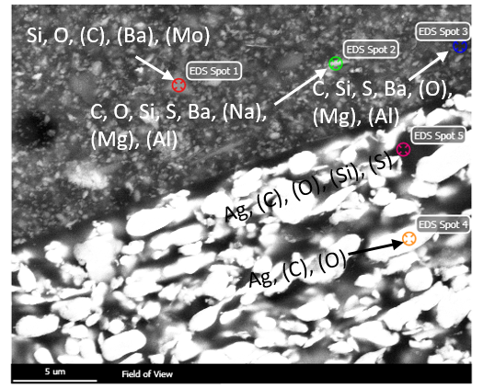

Figure : Zoomed section of Area 5A shown in figure 3

The next area we used our SEM to do an elemental analysis is pictured in figure 5. It shows the zoomed portion of Area 5b. The spot located in the bottom left inside a grey patch contain silicon, aluminum and small amounts of carbon. The second spot we analyzed located at the very top of this figure contains mostly aluminum with small amounts of oxygen, silicon and carbon. Our next spot we analyzed which is in the center of figure 5 within a white spot contains mostly gold with small traces of carbon. EDS spot 4, located to the far right of our figure, is made up of silicon and aluminum with a little carbon, oxygen and iron.

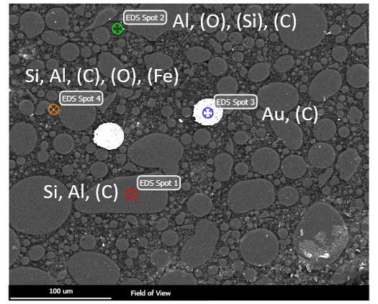

Figure : Zoomed in picture of Area 5B shown in figure 2

We used of SEM equipped with EDS to get the elemental analysis of 6 different spots located in figure 6. The spot located within a grey circle in the top left corner contains silicon, calcium, aluminum and oxygen. The spot located in the black area contains mostly bromine and carbon with a little oxygen and copper. EDS spot 3 which is in the grey area below the black section contains mostly copper with traces of carbon. Our next spot which is below and to the left of EDS spot 3 is analyzing a white speck within the grey area. This spot contains mostly nickel with a little copper and carbon. The spot located in the bottom right corner analyzes the dark grey area within the heterogeneous mix of grey and white. This spot contains a majority of tin with traces of carbon. The spot that’s in the bottom right corner that analyzed the white area contains mostly lead with small amounts of aluminum, carbon, oxygen and tin.

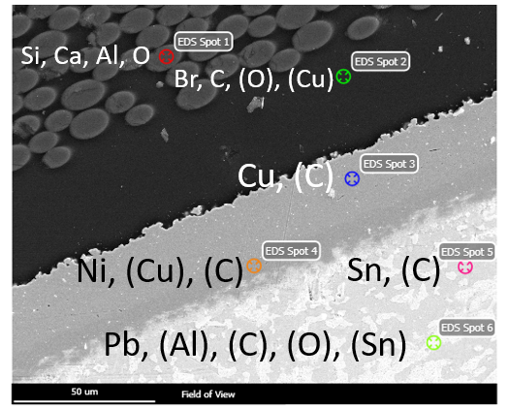

Figure 6: Zoomed section of Area 5C shown in figure 3